IDN-NR-Guidelines for New Store Opening and Store Rejuvenation

Link File: IDN-NR-Task Basic Operations 基础运营

1. Objective
To ensure that all preparations for new store openings and store rejuvenations are completed on schedule, and to allow every person in charge to track task progress until the store operates normally.
If you have any feedback on the SOP, please leave a comment so we can discuss and improve it together.
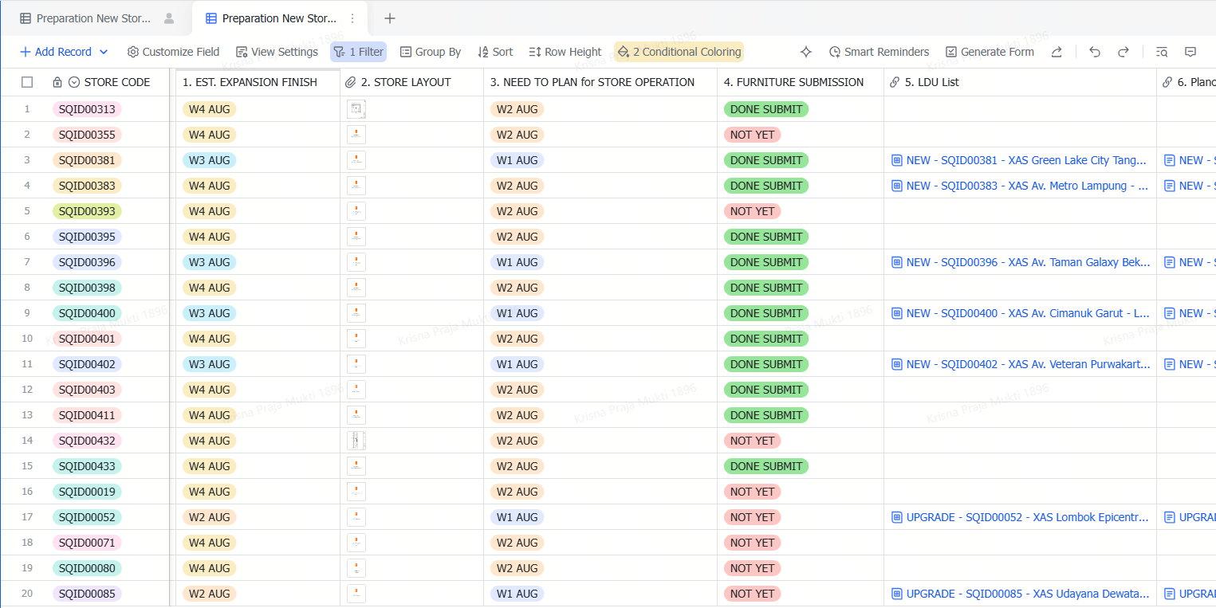

2. Flow Process
In this base link, there are 10 steps process has been prepared for each responsible team member:
2.1 Estimated Expansion Finish  - Responsible: Daniel / Boss Eric (Expansion Team) @Daniel Yuwono@Eric So 蘇紹東  - Task: Input the estimated completion week for construction or renovation. Once completed, the system will send an automatic reminder to the team members responsible for Steps 2 to 4.  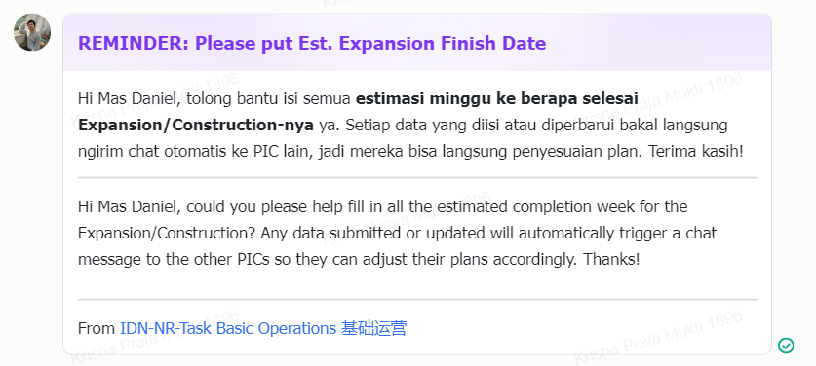  *A daily Automatic Reminder to @Daniel Yuwonoif still didn't put feedback for the Store Estimation Expansion Finish | 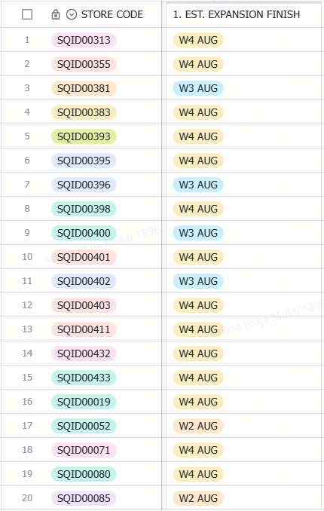  EXAMPLE

2.2 Store Layout  - Responsible: Wiryono (Expansion Team) @Wiryono Situmeang  - Task: Submit the approved store layout. This document serves as the main reference for the Visual Merchandising team to create the Live Demo Unit list and planogram. Submitting this file will trigger an automatic reminder to the Visual Merchandising team for Steps 5 and 6.  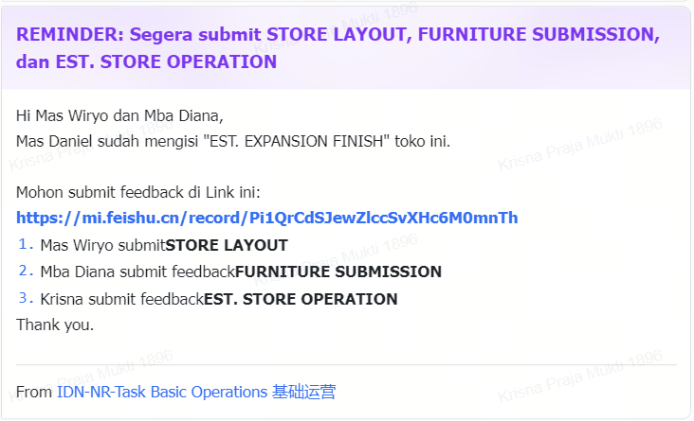  *Automatic reminder to @Wiryono Situmeangand @DIANA PEBRIANTIif Mas @Daniel Yuwonoalready submit the Est. Expansion Finish | 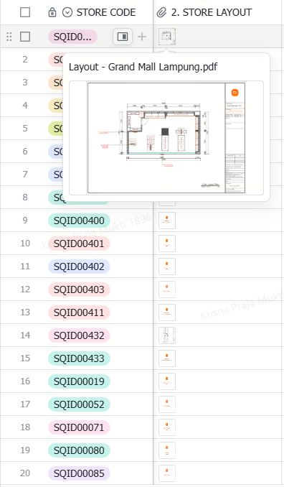  EXAMPLE

2.3 Store Operation Planning  - Responsible: Nikki / Krisna / Fadly (Store Operations Team) @Nikki Chen 陈家璇@Krisna Praja Mukti@FADLY WIRA BAKTI  - Task: Input operational plans. To prevent delay in planning and execution, the estimated operational target date is set two weeks prior to the Estimated Expansion Finish date. Submitting this data will send an automatic reminder to all team members responsible for Steps 4 to 10.  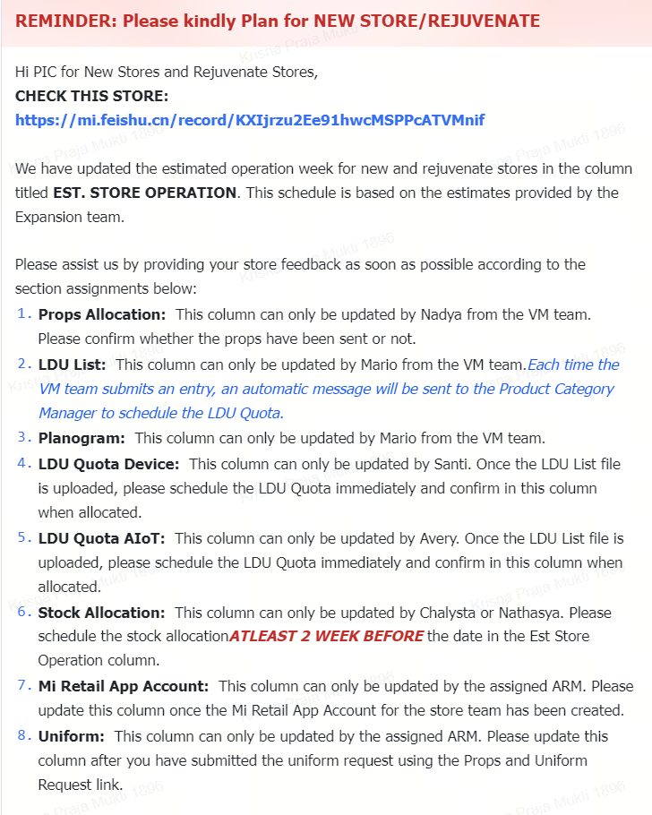  *Automatic Reminder to PIC No 5-10 if the Est. Store Operation already submit | 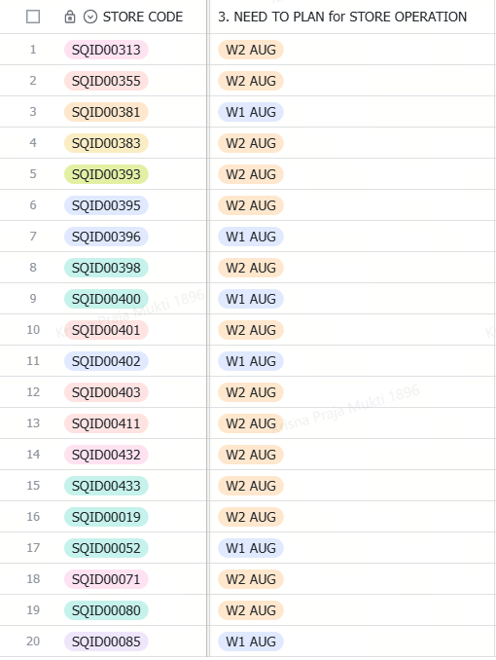  EXAMPLE

2.4 Furniture Submission  - Responsible: Diana (Expansion Team) @DIANA PEBRIANTI  - Task: Submit store furniture data based on the approved layout provided in Step 2. | 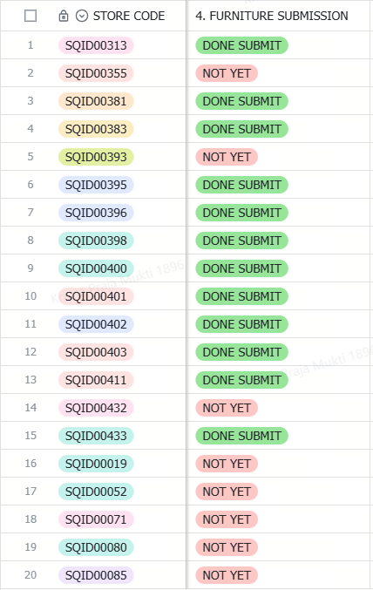  EXAMPLE

2.5 LDU List  - Responsible: Mario (Visual Merchandising Team) @Mario Wahyu  - Task: Create the LDU List based on the layout and furniture details provided in Steps 2 and 3.  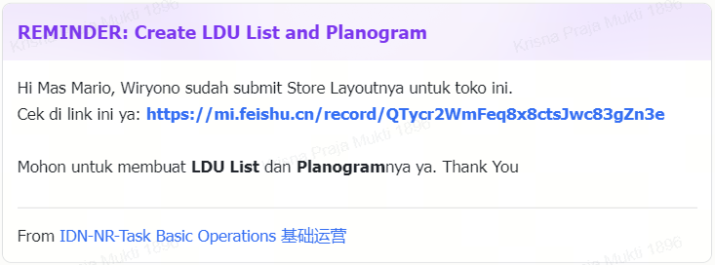  *An Automatic reminder will send to @Mario Wahyuif @Wiryono Situmeangalready submit the Store Layout design | 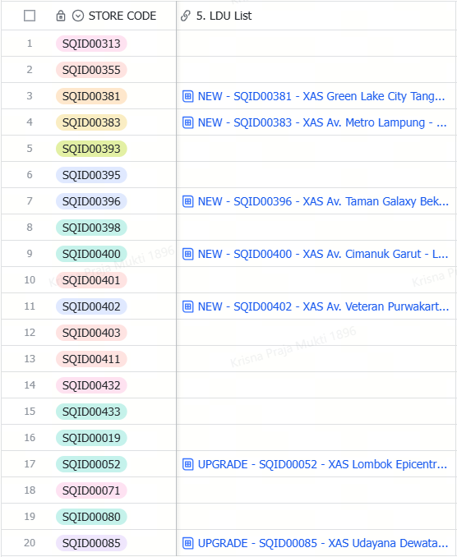  EXAMPLE

2.6 Planogram  - Responsible: Mario (Visual Merchandising Team) @Mario Wahyu  - Task: Create the store planogram based on the layout and furniture details provided in Steps 2 and 3.  *An Automatic reminder will send to @Mario Wahyuif @Wiryono Situmeangalready submit the Store Layout design | 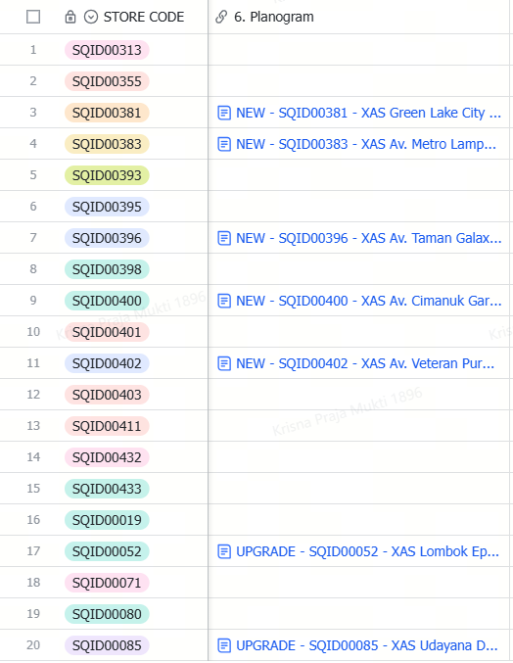  EXAMPLE

2.7 Props Allocation  - Responsible: Mario / Nadya (Visual Merchandising Team) @Mario Wahyu@BAYU NADYA RISKY IRIANTI  - Task: Prepare the allocation for visual props based on the estimated expansion completion date. | 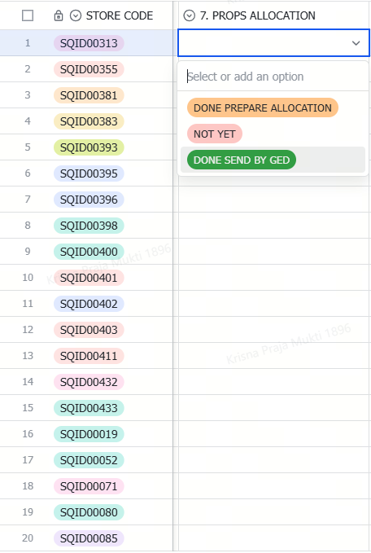  EXAMPLE

2.8 LDU Quota and Stock Allocation  - Device Quota: Santi (Device Product Manager) prepares the device quota plan and submits it into the system based on the list from Step 5. @Santi 曹肖羽  - AIOT Quota: Avery (AIOT Product Manager) prepares the AIOT quota plan and submits it into the system based on the list from Step 5. @Avery Lliu 刘雨航  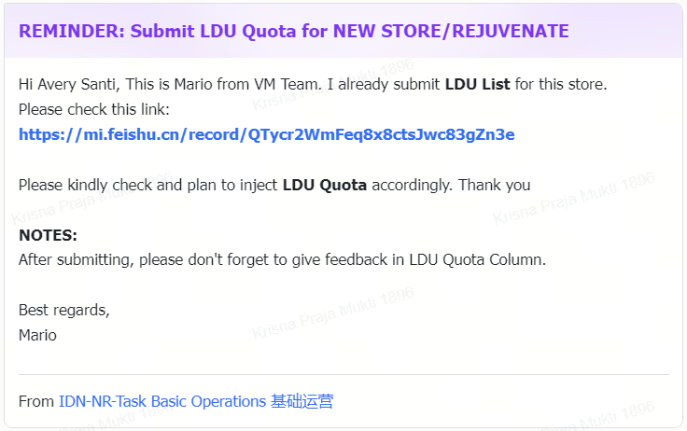  *An Automatic reminder will send to @Santi 曹肖羽and @Avery Lliu 刘雨航if @Mario Wahyualready submit the Store LDU List Plan  - Stock Allocation: Chalysta / Nathasya (Stock Allocation Team) create the stock allocation plan based on the expansion schedule and the submitted demo unit quota. @Chalysta 張凌蓉@Nathasya Tiaman | 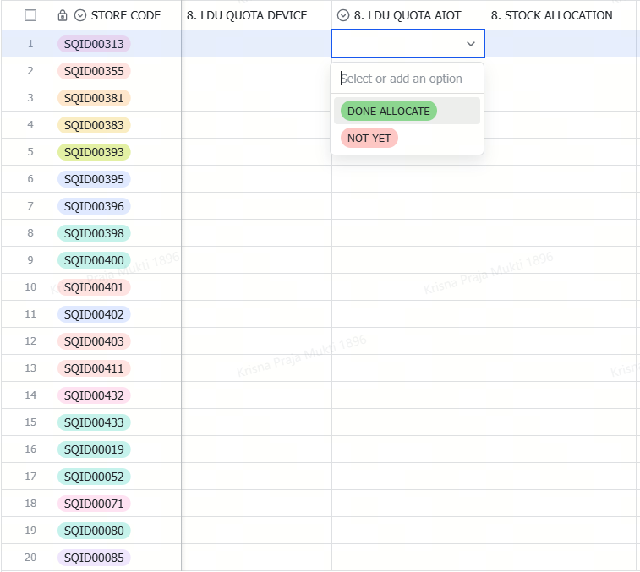  EXAMPLE

2.9 Xiaomi Retail App Account Creation  - Responsible: Area Retail Manager  - Task: Prepare user accounts for the Xiaomi Retail Application for all store personnel, including the Store Leader, Store Consultant, and Frontliner. | 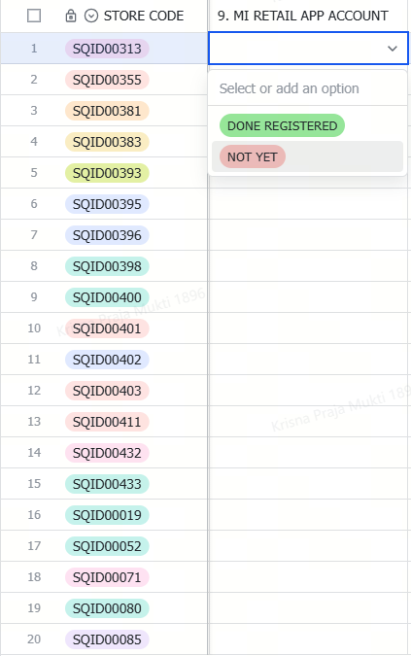  EXAMPLE

2.10 Store Uniform  - Responsible: Area Retail Manager  - Task: Request uniforms for the store team before the expansion or renovation work is complete. | 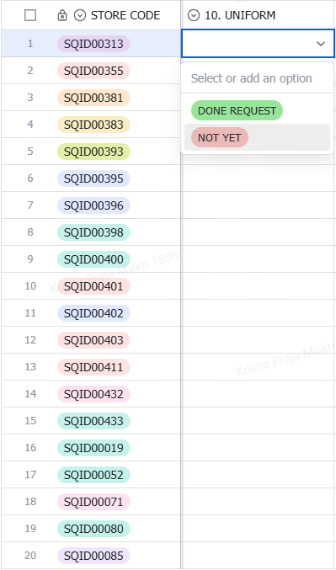  EXAMPLE

